# Project Planning Phase

## Project Planning Template

|  |  |
| --- | --- |
| Date | 15/11/2022 |
| Team ID | PNT2022TMID46314 |
| Project Name | Real-Time Communication System Powered By AI For Specially Abled |

FUNCTIONNAL&OPERATIONEL REQUIREMENT

|  |  |  |  |
| --- | --- | --- | --- |
| **FUNCTION** | **Function (Epic)** | **FunctionStory Number** | **Story / Task** |
| **FUNCTION** 1 | Data collection | F1 | we're collecting dataset for building our project and creating two folders, one for training and another one for testing. |
| **FUNCTION 2** | Image preprocessing | F2 | Importing image data generator libraries and applying image data generator functionality to train the test set. |
| **FUNCTION 3** | Model building | F3 | Importing the model building libraries, Initializing the model, Adding Convolution layers, Adding the Pooling layers, Adding the Flatten layers, Adding Dense layers, Compiling the model Fit and Save the model. |
| **FUNCTION 4** | Testing the model | F4 | Import the packages first. Then we save the model and Load the test image, preprocess it and predict it. |
| **FUNCTION 5** | Application layer | F5 | Build the flask application and the HTML pages. |
| **FUNCTION 6** | Train CNN model | F6 | Register for IBM Cloud and train Image Classification Model. |
| **FUNCTION 7** | Final result | F7 | To ensure all the activities and resulting the final output. |

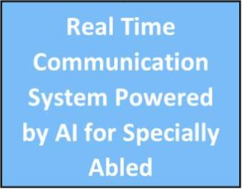

**Technology Used**

**Data Collection**

Collecting dataset for building project

**MySQL & NoSQL**

**Image preprocessing**

Importing the image libraries

**JAVA & PYTHON**

**Model Building**

Importing the model building libraries

**Testing the model**

**Load the test model image, preprocessing and predict it.**

**Machine Learning, CNN & RNN**

**Application layer**

Building flask application

**Train CNN model**

Register for train image classification

**Final Result**

Ensure all activities & getting final output